Introduction
FTS uses the status of bank integrations (used as channel interchangeably) to decide where to route traffic. The status being talked about here is a binary up/down status. Routing in itself uses the up/down status of the bank integrations as an input to deciding the bank integration to which the transfer must go. The exact routing flow is a bit more complicated.

This spec deals with an enhancement in the downtime/uptime detection logic only. All other routing flows are out of scope of this doc. The overall plan/roadmap for all routing changes is given here : https://docs.google.com/document/d/124MYydKvZ5kz-Lj9Sid8nhAQI4gffhwvTy5qYipd2GE/edit

Terminology
- Bank Integration : An integration encapsulates the following
  - Channel
  - Mode
  - mozartIdentifier - version of integration with the bank

L0 Functional Requirements
- Automated aggressive downtime detection of an integration for following cases
  - Attempt TAT degradation
  - Attempt SR dip
  - Single occurrence of documented critical errors : A collection of error codes provided by the banks that should cause instant downtime. No need to wait and use statistical models for analysis before initiating downtime in these cases. Ex : CAPPED_DEBIT
  - Beneficiary registration TAT degradation (Should affect only nodal account traffic)
  - Beneficiary registration SR dip (should only affect nodal account traffic)
- Automated reliable uptime detection of an integration for all system detected downtime
- Manual/Scheduled uptimes to be subject to test traffic before opening the integration for live merchant traffic
- Reducing false downtime detection of an integration due to problems with bene banks
  - Ex : SBI is a major bene bank with ~20% of all traffic. If transfer TAT reduces for only SBI benes due to issues with SBI systems, then currently our statistical models can cause an automated downtime for partner bank integrations.

Non-functional requirements
- Agility
  - Our current architecture is not modular and makes changing statistical models for downtime/uptime detection very difficult. These models should be very easy to change as they are influenced by new learnings and insights on bank behaviour
- Scale
  - The systems should be able to operate under stress of high payout counts.

Current Architecture
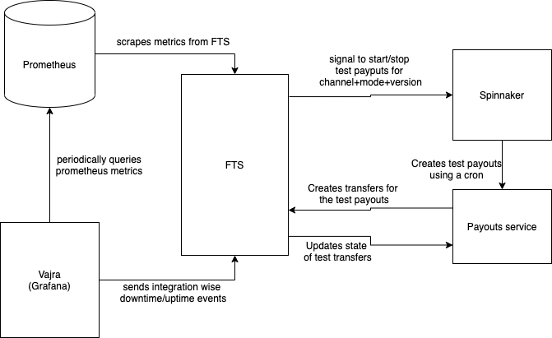

Problems with current Architecture

Currently all system detected downtime/uptime events are powered by a single grafana panel per integration and this brings about the following problems

- Slow detection of downtime
- Fast unreliable detection of uptime
- No test transactions for manual/scheduled uptime. When a manual/scheduled uptime happens, then channel is immediately marked up with no validation of bank performance

Why these issues exist
- We are dependent on Prometheus+Grafana for all the analysis that we need for downtime/uptime detection. Not all triggers for initiating downtime can be optimally modelled using the prometheus data modeling
- The Grafana query semantics are very restrictive and don’t let us optimise our downtime detection algorithms
- Currently downtime/uptime per integration is handled by a single Grafana panel which checks for SR, processed/initiated ratio of transfers, critical errors (eg : CAPPED_DEBIT, etc) and transfer count to calculate uptime downtime. Putting all this in a single dashboard leads to non-optimum downtime detection. For eg : We may need more time to detect SR related issues compared to issues caused by emergence of CAPPED_DEBIT, but right now even the latter kind of issues have to go through the same time for detection.
  - FTS application code cannot at the moment accept information from more than one Grafana panel and aggregate the information. It expects pre-computed boolean information about uptime/downtime events from Grafana.
- Grafana alerting semantics dictate lazy downtime detection and aggressive uptime detection. This is the opposite of what we want
- At the moment in the FTS application, there is no way to subject manual uptimes to test traffic before having them take effect. Application code needs a lot of refactoring to make this happen in a sustainable way.
- There are several problems relating to how we handle test transactions
  - We cannot be alerted when test transfers are not reaching FTS. Test transfers are payouts happening with test merchants, and if the payout fails to reach FTS due to any unforeseen reason, we are not notified.
  - During bank downtimes, transfers can stay in pending for a lot of while causing a lot more status checks than usual leading to pile up in status check queues. This pile up can have the following counter affects
    - TAT for live transfers through the integration can get affected.
    - This pileup can cause high TAT for test transfers until it clears, after the bank comes up. This can affect the time to detect bank uptime. This was experienced in IN-1046
    - Thundering herd effect : If the test transfers were getting stuck during bank downtime, then after the downtime all pending test transfers will start to go to terminal state quickly leading to a lot of test transfers for the same test merchant getting reversed simultaneously. This causes degradation in payout status API of the API monolith. This degradation causes all transfers and payouts to get affected negatively. This was experienced in IN-1046
      - This happens due to merchant level row level locks that payouts has to take to update merchant balance.

In Scope
- Enhancement on fast and reliable downtime detection of an integration
- Enhancement on safe and reliable uptime of an integration

Out of scope
This doc deals with solutioning for marking an integration up/down only.
- How to use this information while deciding which integration a transfer goes through is out of scope.
- All the anti patterns and anomalous behaviours associated with test transactions are out of scope. The topic carries enough complexity and will have a spec for its own. It is also a problem that can be attacked in isolation with other components involving downtime and uptime detection and has so been decoupled.

New Architecture
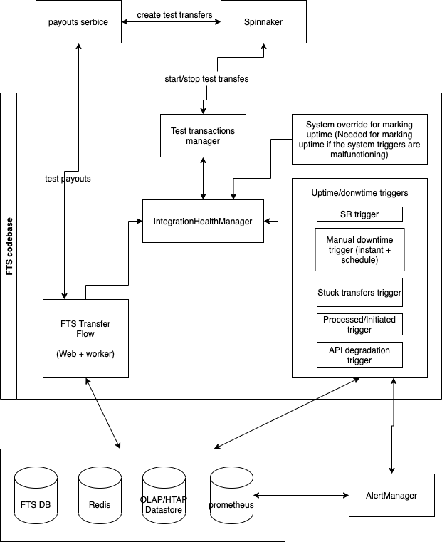

Trigger
A trigger is an entity in FTS code that abstracts one metric for downtime detection. All triggers will be calling methods of the IntegrationHealthManager with events pertaining to detection of downtime/uptime.
The idea is to separate and sandbox the instrumentation and aggregation logic for each trigger. Each trigger will only have awareness and business logic pertaining to the metrics owned by the trigger.

Proposed triggers
- ProcessedByInitiatedTrigger
- SRTrigger
- StuckTransfersTrigger
- TransferAPIDegradationTrigger
- BeneficiaryAPIDegradationTrigger
- StuckBeneficiariesTrigger
- ManualDowntimeUptimeTrigger

Each trigger can be powered by their own instrumentation, DB, code, etc..

IntegrationHealthManager
At the core of the application there stands the IntegrationHealthManager. It has the intelligence to mark a channel Up/Down based on the information provided by triggers. All triggers will call methods of this entity to indicate the status of the ChannelInformation (channel + mode + mozart_identifier + account_type + integration_type) for the metrics/use case owned by them. A ChannelInformation will be marked down if any of the triggers is in an alerting state. A ChannelInformation will be marked up only if all triggers are in ok state.

IntegrationHealthManager is responsible for starting/stopping test transactions on the basis of the information provided by all the triggers at real time.

The methods defined for IIntegrationHealthManager interface are :
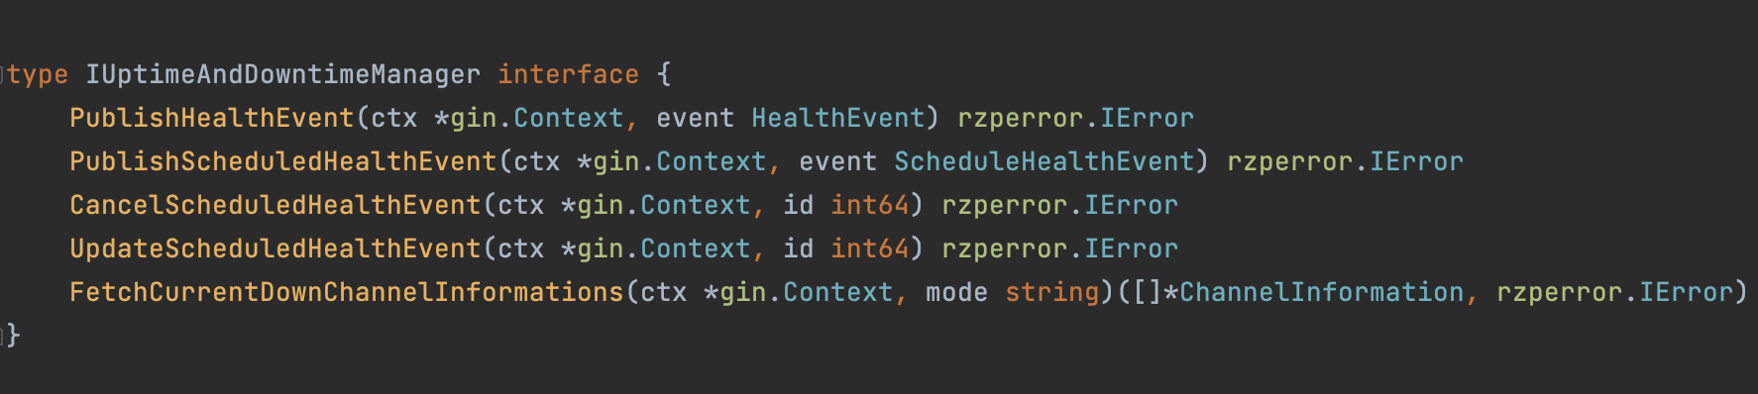

PublishHealthEvent - This is the main method where all the triggers excluding schedule interact to mark a channel down/up instantly. It has intelligence to mark a channel down/up and also decides if test transactions have to be fired or stopped.

PublishScheduledHealthEvent, CancelScheduledHealthEvent, DeleteScheduledHealthEvent - These methods are used to publish/delete/update a scheduled downtime.

FetchCurrentDownChannelInformations - This gives us the current channelInformations which are marked down.

Database changes for routing V2 :
New tables channel_information_status, schedules, trigger_status, channel_information_status_logs, trigger_status_logs will be added where the above methods interact with these tables.

channel_information_status - This table stores the channelInformation and status of it in real time. Whenever a channelInformation has to be marked up/down, we just update the status column of that particular channelInformation.

id | channel | mozart_identifier | integration_type | account_type | mode | status

schedules - This table is used to store the manual/scheduled downtimes. start_from and end_at columns store the timestamp of downtime and uptime respectively.

id | channel_information_id | start_from | end_at | downtime_tag | remarks | triggered_by

trigger_status - This table stores the status of the trigger for a ChannelInformation. There can be many triggers for a single ChannelInformation like SR, API degradation, Processing time, Manual etc.. IntegrationHealthManager checks the status of all the triggers and decides to mark a ChannelInformation up/down.

id | channel_information_id | trigger_name | status

channel_information_status_logs, trigger_status_logs - These tables have the history of data whenever a channel_information and trigger_status is marked up/down.

Dashboard changes for routing V2 :
Existing dashboard of Downtimes will be the same. But we will add two new dashboards to show schedules and trigger’s current status/logs. Schedule dashboard will have an update action corresponding to each entry.

Test transactions manager
A dedicated module that starts/stops test transactions for a ChannelInformation on demand. This will be called by the IntegrationHealthManager as needed.

ITestTransactionsManager interface :
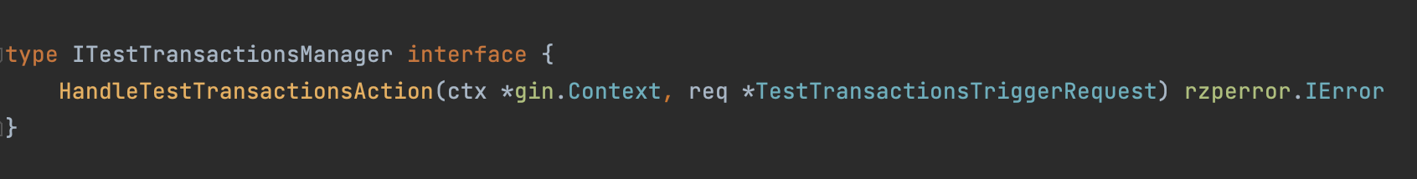

HandleTestTransactionsAction - This method is called by IntegrationHealthManager whenever it needs to start/stop test transactions.

System override for manual uptime
This is needed in case the system triggers are malfunctioning. There can be 2 kinds of malfunction
- System triggers are not detecting downtime when they should
  - In this case the dev/PSE needs to mark the channel down manually using the dashboard. This is something that the proposed architecture supports so no special manual override needed
- System triggers are not detecting uptime when they should
  - In this case the respective bank integrations will never be marked up. This can lead to a lot of problems.
  - Even marking the integration up manually would not work, as the design of the system dictates that manual uptime shall not override any system downtime. This is done to protect against human error where a person manually marks a degraded channel up by mistake.
  - The above case therefore needs a system override mechanism with elevated privileges.

The proposed way of implementing this is having this in the Admin dashboard with only developer access for FTS devs. FTS will expose an API for the same.

API - {http.MethodPost, "/Overridechannelhealth",Post}

This route will be responsible for overriding all the existing triggers. Whole channel will be marked up whenever there is a system override.

Triggers

StuckTransfersTrigger
This trigger captures processing time degradation of a bank. The algo for this trigger is no of transfers which are still pending after t sec of initiating transfer in last X min/ no of transfers initiated in the last X min.

Why it is needed
It is required to capture processing time degradation of a bank.

Trigger implementation

Trigger downtime if the below expression satisfies

Evaluate expr every 2m for 2m

expr : >
( (A / B) * 100 > 20 ) AND (B > 30)
OR
(A / B) * 100 > 60

A - sum(increase(fts_stuck_transfer_count{channel="YESBANK", version="V1", mode="IMPS", product="PAYOUT"}[5m]))

B - sum(increase(fts_time_taken_to_initiate_transfer_count{channel="YESBANK",mode="IMPS",version="V1", product="PAYOUT"}[5m] offset tsec))

Offset tsec - It will get data from T0-t to T5-t instead of T0 to T5.

Trigger uptime if the below expression satisfies

Evaluate expr every 2m for 6m

expr : >
( (A / B) * 100 < 20 ) AND (B > 30)
OR
(A / B) * 100 < 60 AND (B < 30)

SR trigger
This trigger is responsible for monitoring failure rate on a channel. We mark the channel downtime of the number of failures that have breached threshold in a given time span.

Why it is needed
In a scenario where the channel is behaving poorly, we need to use this trigger and mark channel downtime. This helps us in increasing success rate on our transfers

Trigger implementation

ICICI - Downtime -
expr : >
( (A / B) * 100 > 10 ) AND (C > 30)
OR
(A / B) * 100 > 60
A - sum(increase(fts_time_taken_to_process_attempt_count{channel="ICICI", version="V2", status="FAILED", product="PAYOUT",mode="IMPS",bank_error_code!~"INVALID_IFSC|MERCHANT_INVALID_TXN_DETAILS|FROZEN_ACCOUNT|DORMANT_ACCOUNT|TXN_REJECTED_BENE_BANK|NRE_ACCOUNT|CLOSED_ACCOUNT|BENEFICIARY_NAME_MISMATCH|INVALID_BENEFICIARY_ACCOUNT|INVALID_ACCOUNT_NUMBER|BENEFICIARY_MERCHANT|INVALID_BENEFICIARY_DETAILS|INVALID_VPA|MERCHANT_VALIDATION_ERROR|BBANK_OFFLINE"}[10m]))

B - sum(increase(fts_time_taken_to_process_attempt_count{channel="ICICI", version="V2",mode="IMPS", product="PAYOUT",bank_error_code!~"INVALID_IFSC|MERCHANT_INVALID_TXN_DETAILS|FROZEN_ACCOUNT|DORMANT_ACCOUNT|TXN_REJECTED_BENE_BANK|NRE_ACCOUNT|CLOSED_ACCOUNT|BENEFICIARY_NAME_MISMATCH|INVALID_BENEFICIARY_ACCOUNT|INVALID_ACCOUNT_NUMBER|BENEFICIARY_MERCHANT|INVALID_BENEFICIARY_DETAILS|INVALID_VPA|MERCHANT_VALIDATION_ERROR|BBANK_OFFLINE"}[10m]))

C - sum(increase(fts_time_taken_to_initiate_transfer_count{channel="YESBANK", version="V1", mode="IMPS", product="PAYOUT"}[5m]))

Yesbank -

expr : >
( (A / B) * 100 > 15 ) AND (C > 30)
OR
(A / B) * 100 > 60
A - sum(increase(fts_time_taken_to_process_attempt_count{channel="YESBANK", version="V1", status="FAILED",mode="IMPS", product="PAYOUT",bank_error_code!~"BENE_INCORRECT_IFSC|INVALID_IFSC|MERCHANT_INVALID_TXN_DETAILS|FROZEN_ACCOUNT|DORMANT_ACCOUNT|TXN_REJECTED_BENE_BANK|NRE_ACCOUNT|CLOSED_ACCOUNT|BENEFICIARY_NAME_MISMATCH|INVALID_BENEFICIARY_ACCOUNT|INVALID_ACCOUNT_NUMBER|BENEFICIARY_MERCHANT|INVALID_BENEFICIARY_DETAILS|INVALID_VPA|MERCHANT_VALIDATION_ERROR|BBANK_OFFLINE"}[10m])) )

B -
sum(increase(fts_time_taken_to_process_attempt_count{channel="YESBANK", version="V1", mode="IMPS", product="PAYOUT", bank_error_code!~"BENE_INCORRECT_IFSC|INVALID_IFSC|MERCHANT_INVALID_TXN_DETAILS|FROZEN_ACCOUNT|DORMANT_ACCOUNT|TXN_REJECTED_BENE_BANK|NRE_ACCOUNT|CLOSED_ACCOUNT|BENEFICIARY_NAME_MISMATCH|INVALID_BENEFICIARY_ACCOUNT|INVALID_ACCOUNT_NUMBER|BENEFICIARY_MERCHANT|INVALID_BENEFICIARY_DETAILS|INVALID_VPA|MERCHANT_VALIDATION_ERROR|BBANK_OFFLINE"}[10m]))

C - sum(increase(fts_time_taken_to_initiate_transfer_count{channel="YESBANK", version="V1", mode="IMPS", product="PAYOUT"}[5m]))

Uptime -
ICICI
( (A / B) * 100 < 10 ) AND (C > 30)

Yesbank -
expr : >
( (A / B) * 100 < 15 ) AND (C > 30)

API degradation trigger
API degradation trigger will continuously watch the api response time. We will use P80 metrics to find out whether the bank’s are performing well or not.

Why it is needed
The increased response time adds up to overall processing times of a payout. This trigger will help us improve the overall processing by marking down the degraded channel.

Trigger implementation
Using p80 for checking API degradation
Downtime
A > 10 AND B > 20

P80 Query
A - histogram_quantile(0.20, sum by (channel,version,request_stype,le) (rate(fts_mozart_response_delay_bucket{mode=~"$mode"}[2m])))

Query to find out transfer count -
B - sum(increase(fts_time_taken_to_initiate_transfer_count{channel="YESBANK", version="V1", mode="IMPS", product="PAYOUT"}[5m]))

Uptime
For now we are taking look back period to be 2 mins and run this query 5 times in interval of 2 mins
As uptime needs to be lazy and we should be sure for making the channel stable we have take 5 secs as the threshold for stable response

A < 6 AND B > 20

Processed by initiated trigger
This is a lazy check which identifies any edge case in the system when the percentage of processed transfers reduces due to any reason. We’ll use the same instrumentation and algo for now. This will only require refactoring for the FTS code base and new Vajra panels

Why it is needed
It is needed to catch any edge case in the system. While calculating failure rate, we exclude bene error codes and merchant error codes and we don’t mark the channel down even if the bank sends huge no of such error codes. There was an incident where the bank had some issue and sent us a merchant error code which we don’t include in the failure rate. In such edge cases, this check would help in detecting downtime for the bank.

Trigger implementation

Trigger downtime if the below expression satisfies

Evaluate expr every 3m for 3m

expr : >
( (A / B) * 100 < 65 ) AND (C > 30)
OR
(A / B) * 100 < 20

A - sum(increase(fts_time_taken_to_process_attempt_count{channel="YESBANK", version="V1", status="PROCESSED",mode="IMPS", product="PAYOUT"}[5m]))

B - sum(increase(fts_time_taken_to_initiate_transfer_count{channel="YESBANK",mode="IMPS",version="V1", product="PAYOUT",bank_error_code!="BBANK_OFFLINE"}[5m]

C - sum(increase(fts_time_taken_to_initiate_transfer_count{channel="YESBANK", version="V1", mode="IMPS", product="PAYOUT"}[5m]))

Tanay - added this way as it won’t look good in doc if i add alert manager configuration for above multiple nested query. Anyway the other configuration params are the same as sarthak mentioned above. Only expr, for values changes.

Trigger uptime if the below expression satisfies

Evaluate expr every 3m for 6m

expr : >
( (A / B) * 100 < 65 ) AND (C > 30)
OR
(A / B) * 100 > 20 AND (C < 30)

Manual/Scheduled uptime/downtime trigger
This trigger is required to add scheduled/Manual downtimes in the system.

Why it is needed

In some scenarios we mark the system down for an indefinite period or we want to schedule a downtime during the bank's maintenance activity. This trigger will be used for such scenarios.

Trigger implementation

We have created a schedules table which holds information about scheduled downtime.
We will create a scheduler in FTS which will query schedules table in 5 mins of interval to verify whether scheduled downtime has kicked in or not. Scheduled/Manual downtime will be handled using admin-dashboard as it is done at the moment.

API contract - Alert actions
{http.MethodPost, "/channel_health_alerts/:alert_action",Post}

The above api will be used to publish channel health. The api will have four actions -
- Mark Downtime
- Mark Uptime
- UpdateHealthEvent
- CancelHealthEvent

This route will be used by all the alert actions (system triggers) and scheduled/manual actions.

Roll out plan
Tanay Luthra
- Stage 1: FTS refactoring
  - Roll out implementation for IntegrationHealthManager
    - FTS transfer processing flow to use this entity for querying channel+mode+version status before firing a transfer
  - Refactor the existing uptime/downtime marking flow to use this entity
  - Roll out implementation for TestTransactionsManager
    - All test transactions operations to be moved to this implementation for existing flow
- Stage 2: Enhance downtime detection speed and introduce lazy uptime detection for bank processing time degradation
  - Roll out StuckTransersTrigger
  - Roll out APIDegradationTrigger
  - Roll out CriticalErrorsTrigger
  - Attempt level routing
- Stage 3: Deprecate existing routing code by migrating all current routing logic to the new architecture to achieve aggressive downtime and lazy, safe uptime detection for all scenarios
  - Roll out ProcessedByInitiatedTrigger
  - Roll out SRTrigger
- Stage 4: Introduce test transactions for manual/scheduled uptimes
  - Roll out ManualDowntimeUptimeTrigger
- Stage 5: Have automated downtime for issues beneficiary registration APIs and flows
  - Roll out BeneficiaryAPIDegradationTrigger
  - Roll out StuckBeneficiariesTrigger
- Stage 6: Reduce false downtime detections caused due to bene bank issues
  - Release solution document

